Final Checkpoint - Deploying your Laravel project with CI/CD
This guide takes you from a Laravel project on GitHub to a live site at http://<yourprojectname>.austattendance.online, deployed automatically every time you push.
Everywhere you see s<roll>, write your own username. For roll 20230402045 that is s20230402045. Everywhere you see <roll>, write just the number.

Mark distribution
Part | Marks | What is checked
Feature Completion | 5 | The features of your project work on the live site, not only on your laptop.
Database | 3 | Your own <projectname>_db and MySQL user, tables created by Laravel migrations, and the live site reads and writes them. See Step 3.
QA | 2 | The site works end to end without errors: pages load, the React app reaches /api/..., and forms and actions behave as expected.
CI/CD | 10 | A push to GitHub triggers the pipeline, which runs Composer, builds the frontend, and copies the release to the server with scp. The Actions tab shows a successful run.
Total | 20

The rule for marks
Your deployment only counts if the pipeline did it. The pipeline must install the PHP packages with Composer, build the frontend, and copy the result to the server with scp. Copying files to the server by hand does not count. Make sure your instructor can see your repository and its Actions tab.
Make sure your repository is made public before the final checkpoint.

How it works
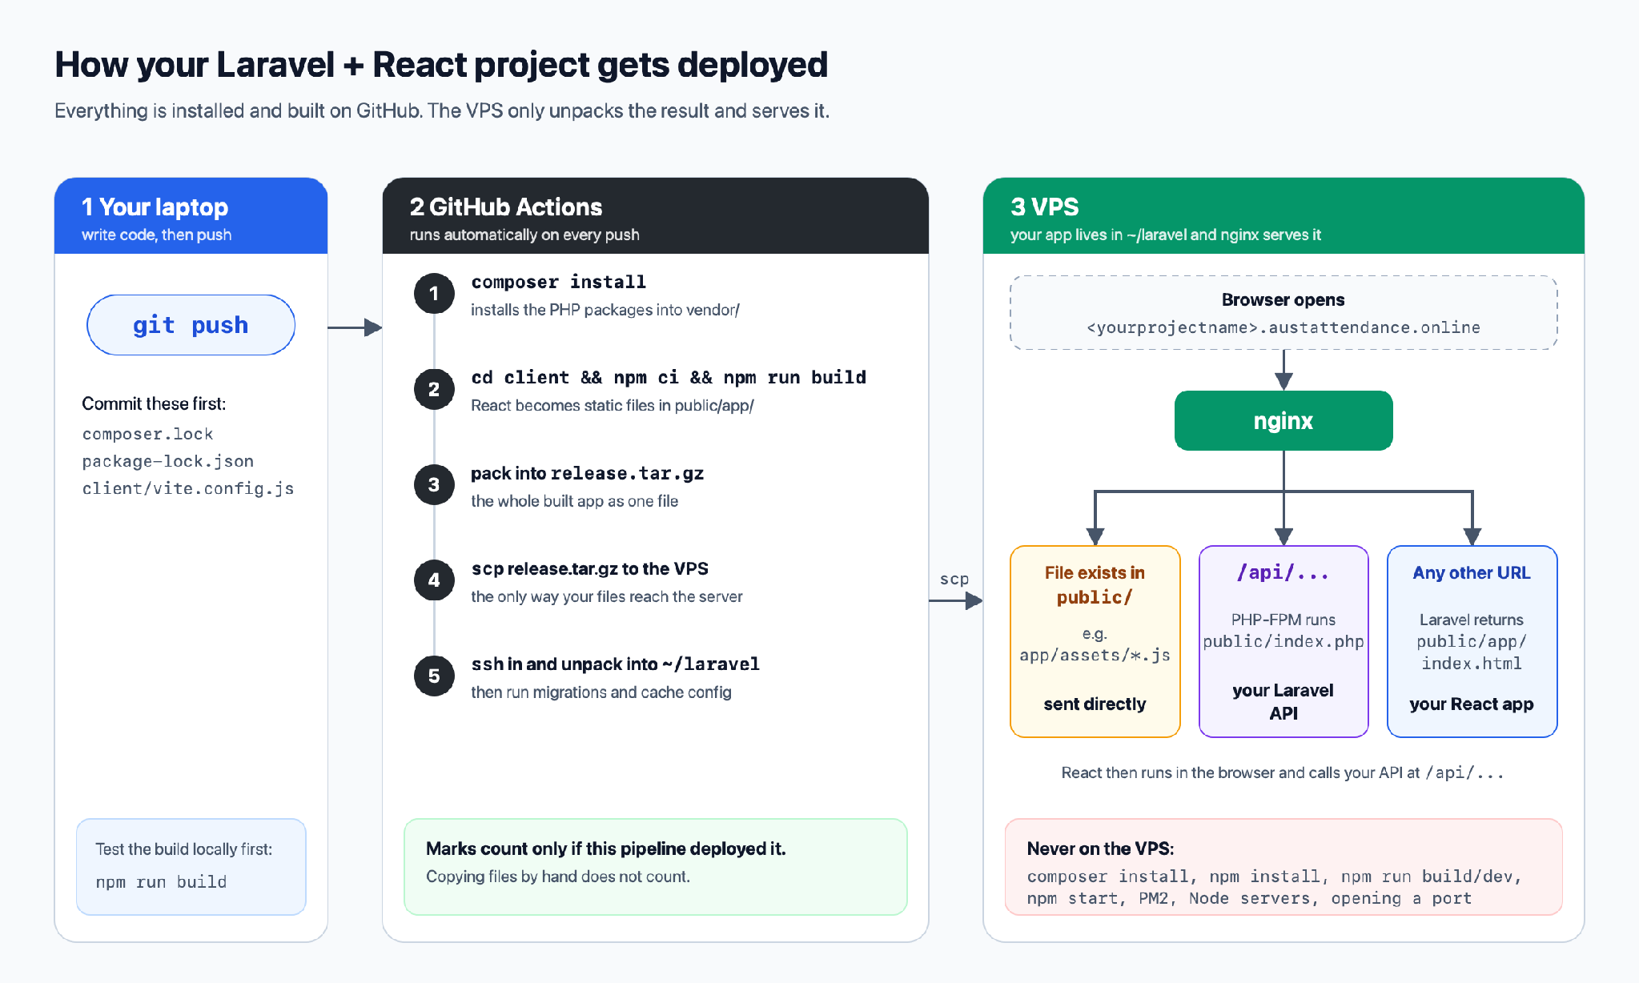
Note: running npm run build turns your react app into plain static files (index.html, JavaScript, CSS). Move those files into laravel's public/app folder. nginx sends those files to the browser as they are. React then runs in the browser and calls your Laravel API at /api/....
Do not run npm run dev, npm run preview, npm start, serve, PM2, or any Node server on the VPS for this project, and do not open a port. The built files in public/app/ are all the server needs for the UI.
The server should never run composer install, npm install, or npm run build. It has one CPU core shared by the whole class. All installing and building MUST happen on GitHub.

Before you start
You need:
- A working SSH login to the server. This should already work from earlier labs:
ssh cse3100
- Your Laravel project in a GitHub repository and with composer.lock and package-lock.json committed.
- The server side prepared by your instructor. Check it after logging in:
ls -l /run/php/php8.4-fpm-s<roll>.sock
If this says No such file or directory, stop and tell your instructor. Your PHP service is not set up yet, and nothing below will work without it.

Step 1: Set up and build your project on your own laptop for testing
Your React app must build into Laravel's public/app/ folder. Open client/vite.config.js and make sure it has the base and build lines:
import react from '@vitejs/plugin-react'
import { defineConfig } from 'vite'

export default defineConfig({
plugins: [react()],
base: '/app/',
build: { outDir: '../public/app', emptyOutDir: true },
server: {
proxy: { '/api': 'http://127.0.0.1:8000' },
},
})
In your React code, call the API with a relative path such as fetch('/api/books'). Do not write http://localhost:8000 or any full address. React and Laravel share one domain on the server, so a relative path works in both places and you need no CORS setup.
React Router handles pages like /books/5 in the browser. When someone opens or refreshes that URL, Laravel must answer with your React index.html. Replace the contents of routes/web.php with:
<?php

use Illuminate\Support\Facades\Route;

// Serve the built React app (client/ -> public/app) for every non-API path.
Route::get('/{any?}', fn () => response()->file(public_path('app/index.html')))
->where('any', '(?!api/|up$).*');
Your API routes stay in routes/api.php, and Laravel serves them under /api/.
Now build everything once, from your project folder:
composer install
cd client
npm install
npm run build
cd ..
After npm run build you should have public/app/index.html and a public/app/assets/ folder. If you do not, check client/vite.config.js again.
Make sure the following files/folders are not committed to git:
vendor
node_modules
client/node_modules
public/app
.env
Laravel's default .gitignore does not know about public/app. Add this line to the .gitignore in your project root if it is missing:
/public/app

Step 2: Prepare your folder on the server
Log in with ssh and run:
mkdir -p ~/laravel/public
setfacl -m u:www-data:x ~ ~/laravel
setfacl -R -m u:www-data:rX -m d:u:www-data:rX ~/laravel/public
What these lines do:
- ~/laravel is where your app will live. The pipeline unpacks into this folder.
- The two setfacl lines let the web server (user www-data) walk into your home folder and read your public/ folder, and nothing else. Your PHP code itself runs as you, so it can read your whole project and write to storage/.

Step 3: Create your database and database user (3 marks)
Your project must use MySQL, and you do not install or run your own MySQL. The
server already runs one MySQL server inside a Docker container called cse3100-db, shared by the whole class. Inside it you create your own database and your own database user, and your Laravel app connects as that user.
If you are using PostgreSQL or something else, you have to migrate it to MySQL.
This step is worth 3 marks. To get them:
- You have your own database, named <projectname>_db.
- You have your own MySQL user, <projectname>, with rights on your database only. Your app must not connect as root.
- Your tables are in your database, created by your Laravel migrations, and your live site reads and writes them.
- Do not create your tables by hand. Your Laravel migrations should create them automatically in the CI/CD pipeline.

Step 4: Create your .env file on the server
Your .env holds secrets, so it never goes into git and the pipeline never touches it. You create it once, by hand, on the server.
nano ~/laravel/.env
Paste this, with your own values:
APP_NAME="My Project"
APP_ENV=production
APP_KEY=base64:paste-your-key-here
APP_DEBUG=false
APP_URL=http://<projectname>.austattendance.online

DB_CONNECTION=mysql
DB_HOST=127.0.0.1
DB_PORT=<port from Step 3>
DB_DATABASE=s<roll>_db
DB_USERNAME=s<roll>
DB_PASSWORD=your-password-here
.....
Use 127.0.0.1 for DB_HOST, not localhost. With localhost, PHP tries a local socket file instead of the port, and fails with No such file or directory.

Step 5: Create your nginx site
nginx is the web server that receives visitors on port 80 and hands requests to your app. It is shared by the whole class, so be careful here.
sudo nano /etc/nginx/sites-available/<projectname>.austattendance.online
Paste this, replacing <projectname> in all places:
server {
listen 80;
server_name <projectname>.austattendance.online;
root /home/s<roll>/laravel/public;
index index.php;

access_log /var/log/nginx/s<roll>-access.log;
error_log /var/log/nginx/s<roll>-error.log;

location / {
try_files $uri $uri/ /index.php?$query_string;
}

location ~ \.php$ {
include snippets/fastcgi-php.conf;
fastcgi_pass unix:/run/php/php8.4-fpm-s<roll>.sock;
}

location ~ /\.(?!well-known) {
deny all;
}
}
What it means: files that really exist in public/, such as your built React files in public/app/, are sent as they are. Every other URL is handed to index.php. Laravel then answers /api/... from routes/api.php, and everything else with your React index.html.
Turn the site on, then test the configuration before reloading:
sudo ln -sf /etc/nginx/sites-available/<projectname>.austattendance.online /etc/nginx/sites-enabled/
sudo nginx -t
Only if nginx -t says syntax is ok and test is successful, reload:
sudo systemctl reload nginx
If nginx -t shows an error, fix your file and test again. Never reload a broken configuration. nginx serves everyone's sites, so a broken config is everyone's problem.

Step 6: Create a deploy key for GitHub
GitHub Actions needs to log in to the server as you. Make a separate key just for the pipeline, so that if it ever leaks you can remove only that one.
On your laptop (Terminal on macOS/Linux, PowerShell on Windows):
ssh-keygen -t ed25519 -f $HOME/.ssh/cse3100_deploy -C "github-actions s<roll>"
When it asks for a passphrase, press Enter twice (leave it empty). A pipeline cannot type a passphrase.
This creates two files:
- cse3100_deploy is the private key. It goes into GitHub secrets and nowhere else.
- cse3100_deploy.pub is the public key. It goes onto the server.
Show the public key and copy the whole line:
cat $HOME/.ssh/cse3100_deploy.pub
Log in to the server and open your list of allowed keys:
ssh cse3100
nano ~/.ssh/authorized_keys
There is already one line in this file. That is your personal key. Do not change or delete it, or you will lock yourself out. Go to the end of the file, press Enter to make a new line, paste the deploy public key, save, and exit.
Back on your laptop, test that the deploy key works:
ssh -i $HOME/.ssh/cse3100_deploy -o IdentitiesOnly=yes s<roll>@187.52.122.100 whoami
It should print s<roll> without asking for a password.

Step 7: Put the private key into GitHub
Show the private key on your laptop:
cat $HOME/.ssh/cse3100_deploy
In your GitHub repository, go to Settings, then Secrets and variables, then Actions, then New repository secret.
- Name: SSH_PRIVATE_KEY
- Secret: paste the private key contents
Click Add secret. GitHub will never show the value again, and it will not appear in logs. Never commit this key to your repository, not even in a private repo.

Step 8: Add the pipeline file
In your project, create the file .github/workflows/deploy.yml. Paste this and change s<roll> on the DEPLOY_USER line to your username:
name: Deploy to VPS

on:
push:
branches: [main]
workflow_dispatch:

env:
DEPLOY_USER: s<roll>
DEPLOY_HOST: 187.52.122.100

jobs:
deploy:
runs-on: ubuntu-latest

steps:
- name: Get the code
uses: actions/checkout@v4

- name: Use PHP 8.4, same as the server
uses: shivammathur/setup-php@v2
with:
php-version: '8.4'

# Add the remaining steps here.
If your main branch is called master, change [main] to [master].
The first two steps are done for you. Write the rest yourself, one - name: step per item below, in this order. Each item says what the step must achieve. Look up the exact commands and actions yourself.
On GitHub (the runner):
- Install the PHP packages. Run Composer for production: no dev packages, an optimized autoloader, and no interactive questions. This creates vendor/.
- Set up Node.js. Use the official actions/setup-node action with a current LTS version.
- Build the React app. Inside client/, install the exact versions from package-lock.json (use npm ci, not npm install), then run the build. Check that public/app/index.html exists afterwards, and fail the step if it does not.
- Pack the release. Make one release.tar.gz of the project. It must contain vendor/ and public/app/. It must not contain .git, node_modules, client/node_modules, or any .env file.
- Load the deploy key. Write the SSH_PRIVATE_KEY secret to a key file with permissions 600, and add the server to known_hosts with ssh-keyscan. Use ${{ secrets.SSH_PRIVATE_KEY }}, never paste the key into the file.
- Copy the release with scp. Send release.tar.gz to your home folder on the server, using DEPLOY_USER and DEPLOY_HOST from the env: block.
On the server (one ssh command from the runner that runs everything below):
- Unpack into ~/laravel. Extract the archive over the existing folder. Your .env there must survive, so check that the archive does not overwrite it.
- Make Laravel's writable folders writable. storage/ and bootstrap/cache/ must be writable by you.
- Run the migrations. Use php artisan migrate with the flag that allows it in production. This is what creates your tables for Step 3.
- Rebuild Laravel's caches. Run php artisan optimize here, on the server. Do not run it on GitHub, because cached config remembers the machine it was built on.
- Clean up. Delete release.tar.gz from the server.
If any command fails, the step must fail and the run must turn red. Do not hide errors with || true.

Step 9: Push and watch it run
git add .github/workflows/deploy.yml
git commit -m "Add deployment pipeline"
git push
Open your repository on GitHub and click the Actions tab. You will see "Deploy to VPS" running. Click it to watch each step. A full run usually takes two to four minutes.
- Green tick: deployed.
- Red cross: click the failed step to read the error, then see Troubleshooting below.

Step 10: Check your site
Open http://<projectname>.austattendance.online in your browser. Your app should load with its styles and JavaScript working.

After you change .env on the server
Laravel caches your configuration, so edits to .env do not take effect by themselves. After editing, run this on the server:
cd ~/laravel && php artisan optimize

Do not
- Do not commit .env, your database file, or any private key.
- Do not run composer install, npm install, or npm run build on the server.
- Do not run your project with php artisan serve, npm run dev, npm run preview, serve, or PM2 on the server.
- Do not commit public/app/. The pipeline builds it.
- Do not edit another student's files or nginx site.
- Do not connect your app to MySQL as root, and do not touch the bookdb database or another student's database.
- Do not start, stop, or restart the cse3100-db container, and do not run your own MySQL container. The whole class shares it.
- Do not reload nginx without a passing sudo nginx -t.
- Do not delete the first line of ~/.ssh/authorized_keys.

Project names

Replace <projectname> with one of the following depending on your own project’s name

paikari
austmate
qurbanix
truthhub
rentora
eduaust
aegis
tripmesh
eventree
toletmama
jobconnect
workforce
rescuebite
mosqueconnect
cleanbee
investbridge
scholarOS
healthylife
dunki
disasterAidBD
drfix
medAlign

